I • Theta Puzzle

The Theta Puzzle consists of a base with 6 positions at the vertices of a regular hexagon and another position at the center, connected as shown in the figure below. There are six tokens labeled A, B, C, D, E and F. A single move of the puzzle is to move a token to an adjacent empty position (along an allowed connection – the line segments in the diagram below). The idea of the puzzle is to start with an initial arrangement of tokens with the center empty and, by a sequence of moves, get to the configuration in the figure below.

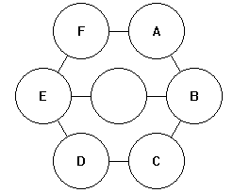

An initial position for the puzzle is given by a permutation of the letters A through F. The first letter starts at A in the figure, the next at B and so on.

A sequence of moves is specified by listing the labels of tokens to be moved, in the order they are to be moved.

For example, to solve the puzzle FACDBE, use the moves BEFAB.

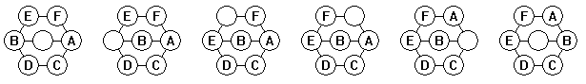

Note: Not all starting permutations can be solved.

Write a program which, given an initial permutation, either finds the shortest sequence of moves to solve the puzzle or determines that there is no solution.

Input

The first line of input contains a single integer P, (1 ≤ P ≤ 1000), which is the number of data sets that follow. Each data set is a single line that contains the data set number, followed by a space, followed by a permutation of the letters A through F giving the initial puzzle position.

Output

For each data set there is a single line of output. If there is no solution, the line contains a decimal integer giving the data set number followed by a single space, followed by the string NO SOLUTION. If there is a solution, the line contains a decimal integer giving the data set number followed by a single space, followed by the number of moves in the solution, followed by a single space, followed by the solution as a string of the letters A through F. If the number of moves is zero (0), you should still output the space after the 0, even though there is no string of letters.

Sample Input | Sample Output
12  1 FACDBE  2 ABCDEF  3 ADCEFB  4 ADCEBF  5 FEDCBA  6 FEDCAB  7 ECBFAD  8 ECBFDA  9 DCEBFA  10 DCEBAF  11 CBEADF  12 BDEAFC | 1 5 BEFAB  2 0  3 19 DABFECABFEDBACDEFAB  4 NO SOLUTION  5 29 BCDEBCAFBCAFBCEDFAECBAFDCBAFE  6 NO SOLUTION  7 19 CBFACBFACDEFACDEFAB  8 NO SOLUTION  9 13 CDAFBEDCBEDCB  10 NO SOLUTION  11 21 DAEBDAEBDCFEBDCABEFAB  12 16 FAEDBCAFBCAFEDCB

